OT Workshop
Building Skills for Independence

Workbook – Session 1

IMPORTANT: This pack is to be completed before the first session. This is very important as the workshop will directly relate to the activities you complete in this pack.

This workbook contains activities which use everyday tasks to help us to explain and demonstrate the concepts as part of the OT Workshop. Some of these activities may not specifically relate to your child’s needs - we do not expect your child to necessarily be able to do these specific tasks and we recognise your child may be quite different from the examples provided throughout this workshop in terms of their age and skill level. The examples presented in this workbook and workshop are for the purpose of creating discussion and helping you apply the thinking to your own child.
Overview
- This pack is to be completed before the first workshop. This is very important as the workshop will directly relate to the activities you complete in this pack.

- There are 3 activities to complete in this booklet.

- Please complete the activities in the order of this booklet.

SESSION 1: pre- activities
Activity 1: Video and PEOS
The first activity involves watching a video. While you are watching the video, we would like you to think about the following P, E, O and S:
- The Person (P):
  - Age of the child?
  - What parts of his body does he need to use for the task?
  - Level of calmness?
  - Level of focus?
  - Does the child want to do the task?
  - Does he understand the task?

- The Environment (E):
  - Where is the task being completed?
  - What is in the surroundings?
  - Noise and sounds
  - Lighting
  - Temperature
  - Other people in the environment.

- The Occupation (O - task):
  - What is the task?
  - What items/tools/equipment are used for the task?
  - Does the child know the steps?
  - How long does the task take?
  - What time of day is the task completed?

- The Supporting Adult (S):
  - What does the adult helping the child do?
  - How does the adult support the child?
  - How much support does the adult give the child?
While you are watching the video and thinking about the Person (P), Environment (E), Occupation (O - task) and Supporting Adult (S).
Please write notes under each of these sections.
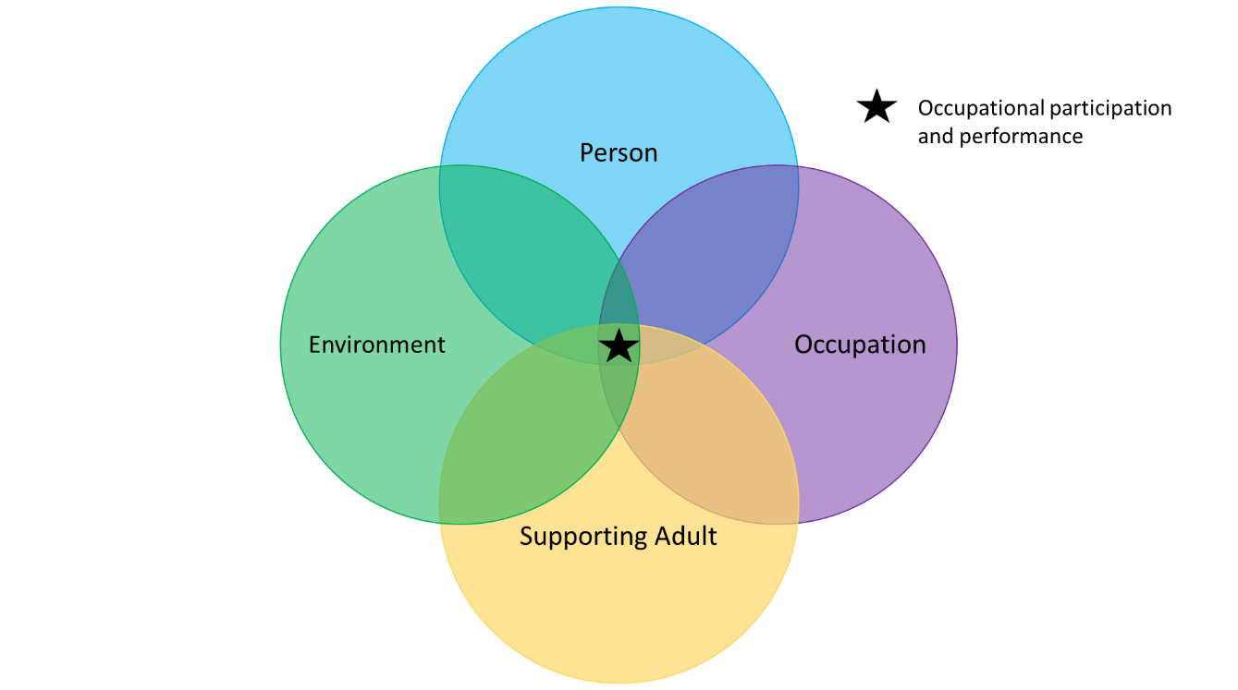

There are PEOS circles on the next page if you would like to write notes there.
The video link is located on the page after the PEOS circles.

Occupation

Person

Supporting Adult

Environment

You can now watch the video by either going to:
https://www.youtube.com/watch?v=zMmokbfmydI

OR

Go to YouTube and type in: ‘kid wearing shoes’, it is the first video in the search results. The video duration is 3 minutes : 19 seconds

PLEASE NOTE: YOU MUST WATCH THE VIDEO BEFORE THE ONLINE WORKSHOP AS THE VIDEO WILL BE DISCUSSED DURING THE WORKSHOP.

Once you have watched the video and written in the circles, please go to the next page.

Activity 2: Breaking a task into steps
For this activity we would like you use the lines below to briefly write out the steps for how you would make a cup of tea.

_____________________________________________
_____________________________________________
_____________________________________________
_____________________________________________
_____________________________________________
_____________________________________________
_____________________________________________
_____________________________________________
_____________________________________________
_____________________________________________
_____________________________________________

Once you have completed the above, please go to the next page.

We would now like you to put a number in the boxes above each picture to show which order you do that particular step. For example, if you get a spoon from the drawer as the fourth step, put a ‘4’ in the box next to that picture. If you do not have lemon, sugar etc. please put a cross in the square in the box above this picture.
Once you have numbered all the squares – please keep a record of this by taking a photo or writing into this document. The numbered boxes will be discussed during the workshop. Double click into the box (if on a computer)

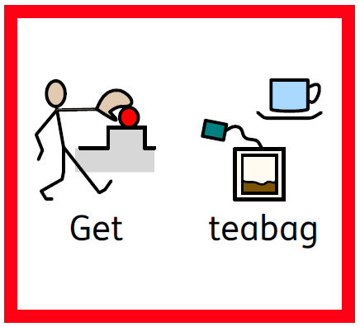
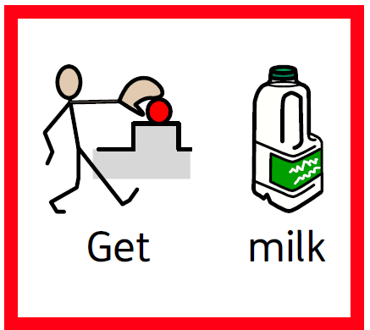
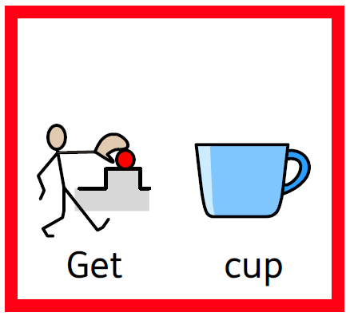
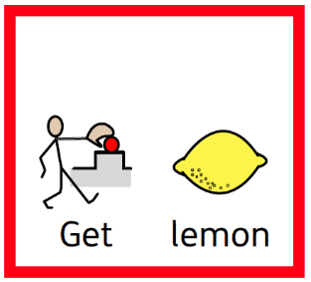
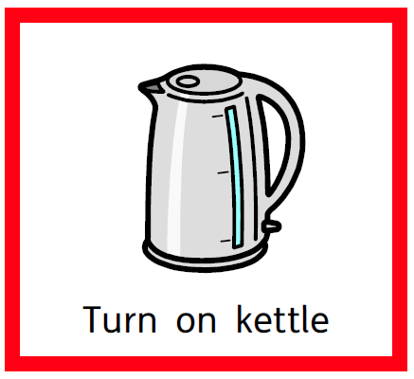
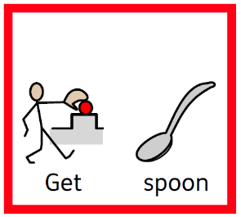

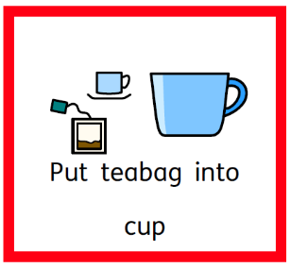
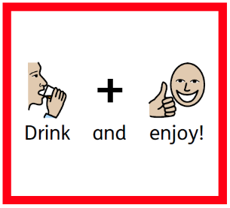
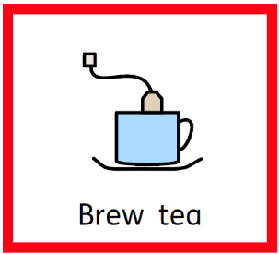
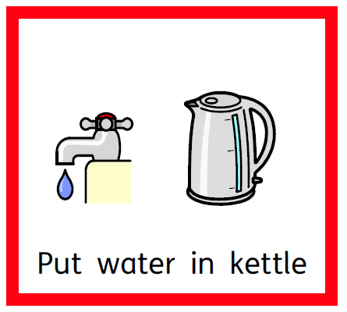

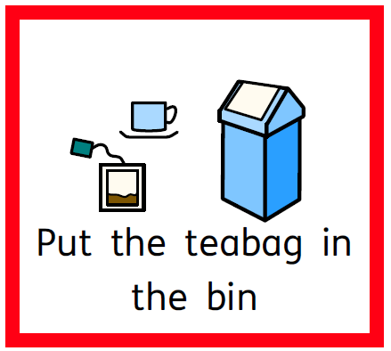

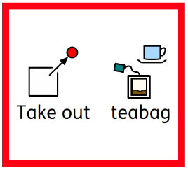
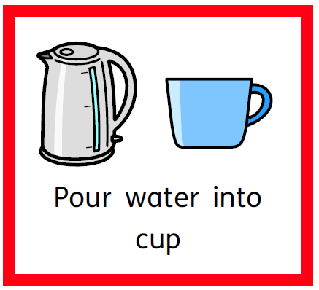

Activity 3: The ‘Person’ circle for your own child
Please complete the ‘Person’ circle for your own child. Feel free to type in the circle or draw on a separate piece of paper.
Person

You have now completed all the activities in preparation for the workshop.
IMPORTANT for the workshop:
- If you:
- Can’t make the workshop
- Aren’t able to access the virtual link, or
- Don’t think you will be able to complete the activities in this pack before the workshop
Please contact 0203 049 8181 or 07598 552 396 to cancel your attendance at the workshop – Please leave your name, child’s name, child’s DOB and NHS number when you call. Someone will contact you to reschedule this appointment for a more appropriate time. Please note all staffing levels are reduced at the moment and this may result in slightly longer timeframes to return your call.
- If you do not attend the virtual workshop and do not give prior warning, your child may be discharged from the service.

- If you are late by 10 minutes or more, you will be asked to contact 0203 049 8181 or 07598 552 396 to re-book within 2 weeks.

- The online workshop will likely run for 1-1.5hours so please allocate enough time to complete the workshop.

- Online workshop rules: it can be really tricky to have everyone online and try to talk at the same time so here are a few ground rules to make it easier for everyone:
  - Keep your microphone on mute while you are not talking – this can be done by clicking on the microphone icon.
  - If you would like to talk, click the microphone icon to un-mute.
  - Say your name first and then ask or discuss what you would like.

- Please bring a copy of the completed activities to the online workshop as we will discuss these. It is ok to write or complete these activities on a separate sheet of paper if needed.

- Your workshop session may be recorded for training and development. The recording will only be used internally within the department for the purposes of reviewing the workshop structure and content and will not be shared with any external parties. Please let us know if you do not wish for your session to be recorded.

We look forward to seeing you in the online workshop you booked into!
Kind regards,
The Children’s Occupational Therapy Team

