OT Workshop
Building Skills for Independence

Workbook – Session 2

IMPORTANT: This pack is to be completed before the second workshop. This is very important as the online workshop will directly relate to the activities you complete in this pack.

Summary of Session 1
Use P, E, O and S circles to break down the video.
It is important to consider the following for any task or action:
- Is there something that can be done to support the PERSON?
- Is there something that can be changed in the ENVIRONMENT?
- Is there something we can change for the TASK?
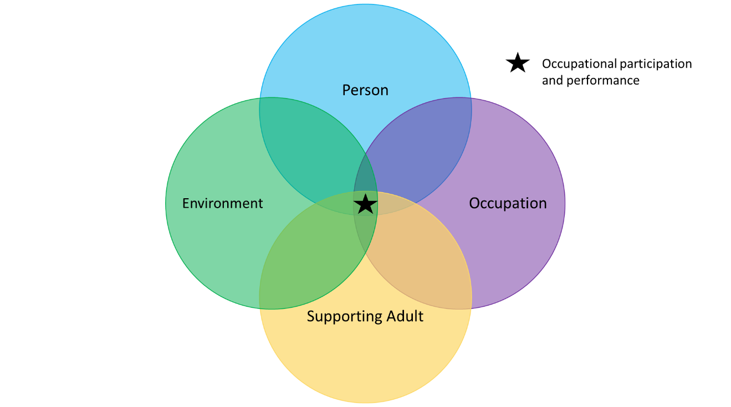
- Is there something we can change for how the adult SUPPORTS in the task?
Breaking down the steps for a task
It is important to consider the following for any task or action:
- What are all the steps involved (no matter how small)?
- Is there certain steps that are tricky for your child?
- How can we teach these steps?
- Is there a different way we can teach a task to make it easier to learn?

Activity 2: The circles for your own child
Please complete the ‘Occupation, Environment and Supporting Adult’ circle for your own child’s goal.

For the ‘Occupation’ circle think back to “Making Cup of Tea” activity. What are the steps of this goal? Can the task be broken down to even smaller steps? Where might the task be breaking down for your child?

For the ‘Environment’ circle think about where this task is being completed. Is this the best location for your child? Are there any distractions? Is all needed equipment available? Is there adequate time?
For the ‘Supporting Adult’ circle think about who are the supporting adults? Is there consistency in the way an activity is being taught? Is ‘just the right’ amount of help being provided?
Occupation

Person

Supporting Adult

Environment

You have now completed all the activities in preparation for the group.
IMPORTANT for the workshops:
- If you:
- Can’t make the workshop session
- Aren’t able to access the virtual link, or
- Don’t think you will be able to complete the activities in this pack before the workshop
Please contact 0203 049 8181 or 07598 552 396 to cancel your attendance at the workshop– Please leave your name, child’s name, child’s DOB and NHS number when you call. Someone will contact you to reschedule this appointment for a more appropriate time. Please note all staffing levels are reduced at the moment and this may result in slightly longer timeframes to return your call.
- If you do not attend the virtual workshop and do not give prior warning, your child may be discharged from the service.

- If you are late by 10 minutes or more, you will be asked to contact 0203 049 8181 or 07598 552 396 to re-book within 2 weeks.

- The online workshop will likely run for 1-1.5 hours so please allocate enough time to complete the workshop

- Online workshop rules: it can be really tricky to have everyone online and try to talk at the same time so here are a few ground rules to make it easier for everyone:
  - Keep your microphone on mute while you are not talking – this can be done by clicking on the microphone icon.
  - If you would like to talk, click the microphone icon to un-mute.
  - Say your name first and then ask or discuss what you would like.

- Please bring a copy of the completed activities to the online workshop as we will discuss these. It is ok to write or complete these activities on a separate sheet of paper if needed.

- Your workshop session may be recorded for training and development. The recording will only be used internally within the department for the purposes of reviewing the workshop structure and content and will not be shared with any external parties. Please let us know if you do not wish for your session to be recorded.

We look forward to seeing you in the online workshop you booked into!
Kind regards,
The Children’s Occupational Therapy Team

