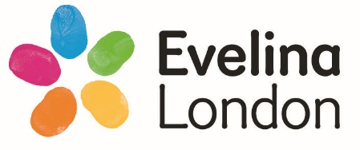


OT Workshop
Building Skills for Independence
This handout contains resources to support the workshop. Your Occupational Therapist will explain how to use this resource.
Here is the “Person, Environment, Occupation and Supporting Adult model” (PEOS):
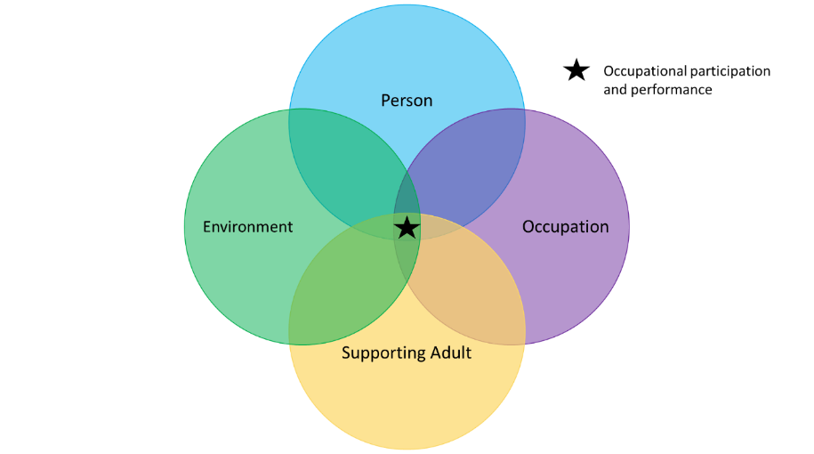

© 2017. All rights reserved. Guys and St Thomas NHS Foundation Trust

While you think about your child and their goal use the following questions:
- The Person (P):
  - Does your child want to do the task?
  - Do they understand the task?
  - What do they like?
  - What are they good at?
  - What parts of their body do they need to use for the task?
  - Are they focused on the task?

- The Environment (E):
  - Where is the task being completed?
  - What is happening around your child?
  - Are there any distractions?
  - Noise and sounds?
  - Lighting?
  - Temperature?
  - Other people in the environment and what are they doing?

- The Occupation (O - task):
  - What is the task?
  - What things do you need for the task?
  - Are the things you need ready?
  - Does the child know the steps?
  - How long does the task take?
  - What time of day is the task completed?

- The Supporting Adult (S):
  - Who are the adults that help your child?
  - What is the adult helping your child do?
    - Talking
    - Pointing
    - Showing
    - Doing
  - How does the adult support your child?
  - How much support does the adult give the child?

On the next page you will find a copy of the PEOS model which you can complete, thinking about your child and their goal.

Occupation

Person

Supporting Adult

Environment

The CPA form will be introduced at the end of the second session:
Collaborative performance analysis (CPA) form
Parent’s goal:
Date:
Parent’s name:
Child’s name:

Parent’s homework:
What might help?
What have I tried?
What is difficult?
What is going well?

Please have this with you during your next session

EXAMPLE
Collaborative performance analysis (CPA) form
Parent’s goal: To put on a shirt
Date:
Parent’s name: XXX
Child’s name:

Parent’s homework:
What might help?

-Try in front of a mirror

-Use prompt “label at the back”
What have I tried?

-Showing them how to do it
-Telling them what to do
What is difficult?

-They put it on wrong way around
-They get frustrated when makes mistake
What is going well?

-Child is motivated to try
-They can do it sometimes

Please have this with you during your next session

IMPORTANT for the workshop:
- If you:
- cannot make the workshop
- are not able to access the virtual link
Please contact 0203 049 8181 to cancel your attendance at the workshop – Please leave your name, child’s name, child’s DOB and NHS number when you call. If you do not attend the workshop and do not give prior warning, your child will discharged from the service.
If you are required to cancel your first session you will be placed back onto the waitlist for workshops. If you are unable to attend the second offer of workshops then you may be discharged.

- If you are late by 20 minutes or more, you will be asked to contact 0203 049 8181 to re-book within 2 weeks, we will not be able to accept you into the workshop.

- The workshop will likely run for 1-1.5hours so please allocate enough time to complete the workshop.

- Your workshop session may be recorded for training and development. The recording will only be used internally within the department for the purposes of reviewing the workshop structure and content and will not be shared with any external parties. Please let us know if you do not wish for your session to be recorded.

We look forward to seeing you at the workshops!
Kind regards,
The Children’s Occupational Therapy Team

